Bluetooth Arduino->Téléphone

#include <SoftwareSerial.h>

SoftwareSerial BTSerial (10,11); // TX : 10 RX: 11

void setup() {

Serial.begin (9600);

BTSerial.begin (9600);

pinMode(2,OUTPUT);

pinMode (8,INPUT);

}

void loop() {

if (digitalRead (8) == 1){

BTSerial.write("1");

Serial.println("oui");}

if (digitalRead (8) == 0){

BTSerial.write("0");

Serial.println("non");}

delay(200);

Serial.println(BTSerial.readString());

}

CommandeVocaleMITMindstorm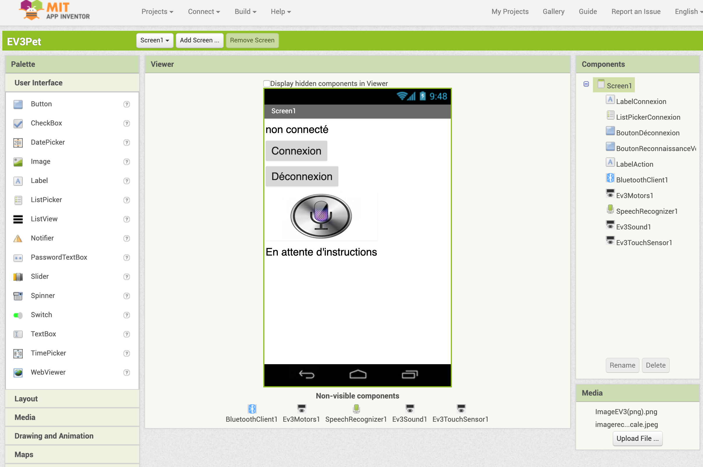

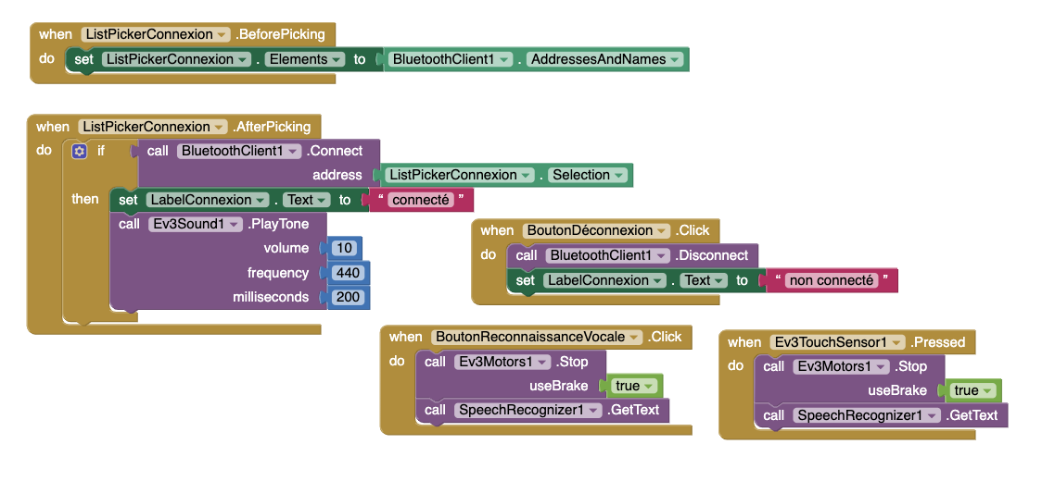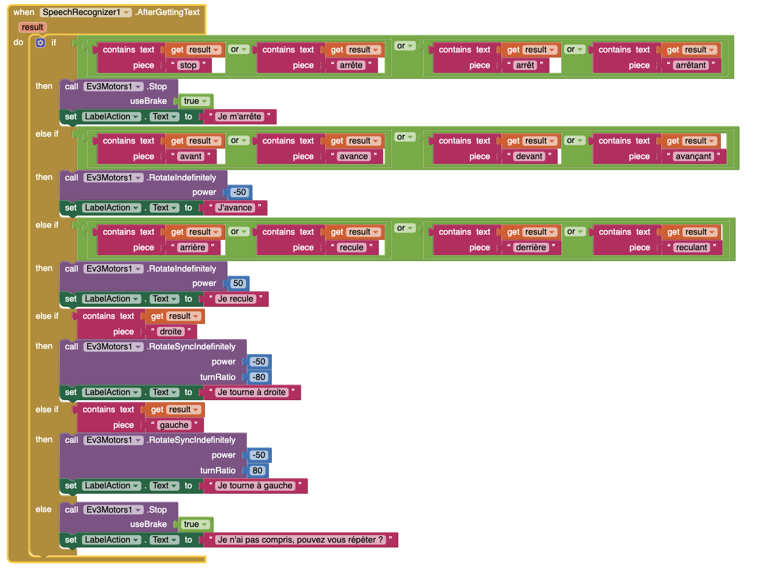

CommunicationBluetoothCommunicationBluetoothTéléphone->Arduino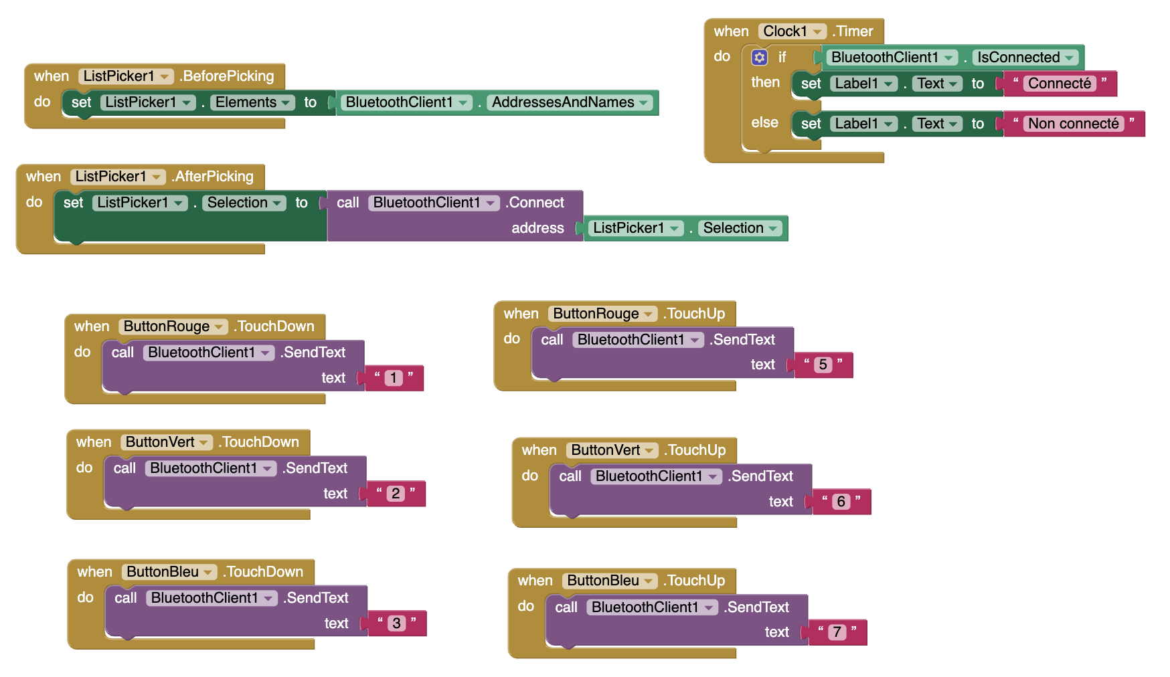

#include <SoftwareSerial.h>

int message = 0;

int R = 2;

int G = 3;

int B = 4;

SoftwareSerial BTSerial (10,11); // TX : 10 RX: 11

void setup() {

Serial.begin (9600);

BTSerial.begin (9600);

}

void loop() {

if (BTSerial.available() > 0 ){message = (BTSerial.read()-48);}

Serial.println (message);

if (message==1){digitalWrite(R,1);}

if (message==2){digitalWrite(G,1);}

if (message==3){digitalWrite(B,1);}

if (message==5){digitalWrite(R,0);}

if (message==6){digitalWrite(G,0);}

if (message==7){digitalWrite(B,0);}

delay(100);

}

Communication Bluetooth Téléphone -> Arduino (Binaire)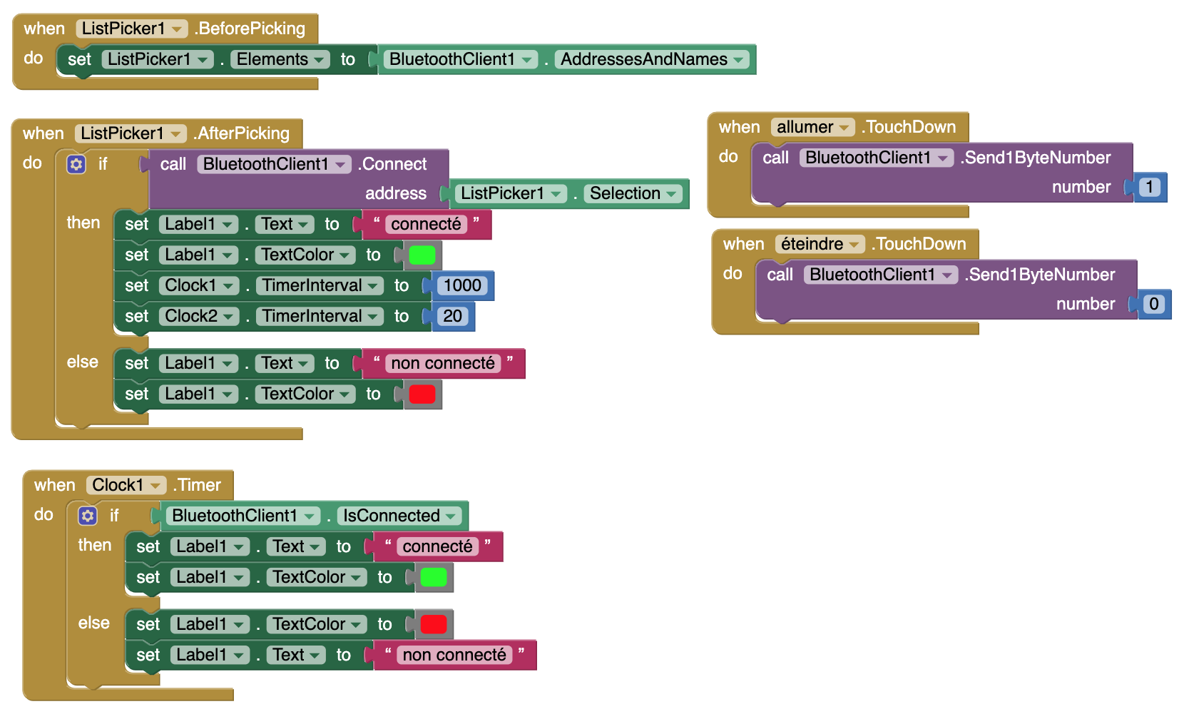

#include <SoftwareSerial.h>

SoftwareSerial BTSerial (10,11); // TX : 10 RX: 11

void setup() {

Serial.begin (9600);

BTSerial.begin (9600);

pinMode(2,OUTPUT);

pinMode (8,INPUT);

}

void loop() {

int message = BTSerial.read();

Serial.println (message) ;

if (message == 1){

digitalWrite(2,HIGH);}

if (message == 0){

digitalWrite(2,LOW);}

}